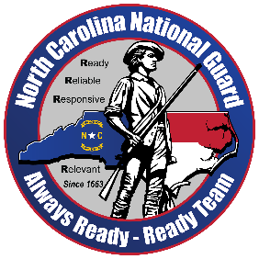
NORTH CAROLINA NATIONAL GUARD MEDIA ADVISORY

For more information contact:

CPT Shamari Pratt

North Carolina National Guard

Office of Public Affairs

shamari.d.pratt.mil@army.mil

910-674-2817

Oct 4, 2025

Media Advisory: 130th Headquarters & Headquarters Company Mobilization Ceremony

What: A ceremony will be held for approximately 150 members of the 130th Maneuver Enhancement Brigade, North Carolina National Guard, that are mobilizing in support of the Southern Border Mission, Texas U.S.

When: Oct 4, 2025, at 10:00 EST.

Where: NC Air National Guard Wing, 4930 Minuteman Way, Charlotte, NC 28208. (Military escort required)

Media Contact on Site: Capt. Shamari Pratt, 910-674-2817

Special Instructions: Media is being asked to arrive no later than 9 a.m. on Oct. 4, 2025, at 4240 West Boulevard Charlotte NC 28208 to be shuttled to the ceremony on Oct 4, 2025. State ID is required.

Please rsvp NLT 12 noon on Friday Oct 3, 2025. CPT Shamari Pratt, 910-674-2817, shamari.d.pratt.mil@army.mil

NCNG PAO will provide high-resolution photos after the event at https://www.flickr.com/photos/ncngpao/albums.

