|  |
| --- |
| **NORTH CAROLINA NATIONAL GUARD MEDIA ADVISORY** |

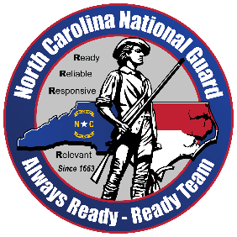

**For more information contact:**

Lt. Col. Ellis Parks

North Carolina National Guard

Office of Public Affairs

September 25, 2025

**The North Carolina National Guard Remembers the One Year Anniversary of Hurricane Helene**

The North Carolina National Guard (NCNG) is reflecting on its lifesaving efforts during Hurricane Helene, highlighting the dedication of Soldiers and Airmen who supported communities across the state in the storm’s aftermath.

Working alongside state, local, and federal partners, the NCNG carried out an unprecedented mission to rescue, sustain, and support North Carolinians when they needed it most.

Key accomplishments included:

* 869 people and 226 pets rescued
* 20,667 tons of ground cargo delivered
* 1,877 tons of air cargo transported
* 661,260 gallons of water distributed
* 3,638 food pallets and 5,306 water pallets delivered
* 886 people relocated to safety
* 468 air missions and 1,876 ground missions completed
* 1,615 obstacles cleared from critical routes

The NCNG remains “Always Ready, Always There” to serve its communities during natural disasters, providing both immediate relief and support.

###

NCNG Logo

<https://www.flickr.com/photos/ncngpao/52451321266/in/datetaken/>

Email

ng.nc.ncarng.mbx.pao@army.mil

[Photos and Videos: Tropical Storm Helene Response | Flickr](https://www.flickr.com/photos/ncngpao/albums/72177720320679746/)

[DVIDS - NC National Guard Responds to Tropical Storm Helene (dvidshub.net)](https://www.dvidshub.net/feature/NorthCarolinaNationalGuardHelene#:~:text=Helene%20impacts%20are%20widespread%20flash%20flooding,%20landslides,%20damaging%20debris%20flows,)

[NCNG YouTube Helene Playlist](https://youtube.com/playlist?list=PLBG1wMWa3-EhdLtD73yISS9d9FJN4uFdZ&si=T1lb9Ys-Qv13NICO)