**BRIGADIER GENERAL SHAWNE M. JOHNSON**

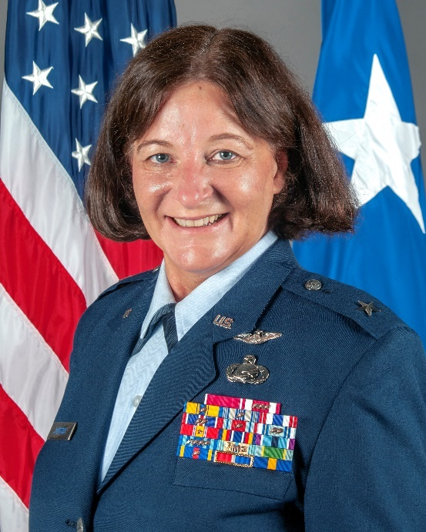Brig. Gen. Shawne M. Johnson serves as the Chief of Staff for the North Carolina Air National Guard. She is responsible for the coordination and direction of JFHQ Air Staff activities in support of the over 1,400 Airmen of the NCANG and serves as a principal advisor to the Adjutant General and Assistant Adjutant General for Air. She advises the Adjutant General and Assistant Adjutant General for Air on policies and programs affecting military personnel and operations for the North Carolina Air National Guard. General Johnson also develops and implements new missions as appropriate for the North Carolina Air National Guard.

General Johnson enlisted in the North Carolina Air National Guard as an Aeromedical Evacuation Technician in 1986. She received a direct commission in the Medical Service Corps in 1996. Throughout her career she has served in numerous leadership positions within personnel, services, force support and human resources, to include North Carolina’s J9 Director of Soldier and Airmen Support Services and the State’s Human Resource Officer. General Johnson served as commander for the 145th Mission Support Flight, 145th Force Support Squadron, and 145th Mission Support Group. She also served as Joint Task Force Commander for the 2019 U.S. Africa Command Exercise UPWARD MINUTEMAN in Botswana. Prior to her current assignment she served as Commander for the 145th Mission Support Group.

**EDUCATION**

1996 Bachelor of Arts in Biology, University of North Carolina at Charlotte

2004 Squadron Officer School, by correspondence

2011 Air Command and Staff College, by correspondence

2016 Air War College, by correspondence

2019 Commanders Development Course, Joint Base Andrews, Md.

**ASSIGNMENTS**

1. December 1996 - June 1999, Medical Service Corps Officer, 156 Aeromedical Evacuation Squadron, Charlotte, N.C.

2. June 1999 - September 2005, Personnel Officer, 145 Mission Support Flight, Charlotte, N.C.

3. September 2005 - August 2009, Commander, 145 Mission Support Flight, Charlotte, N.C.

4. September 2009 - May 2010, Force Support Officer, 145th Force Support Squadron, Charlotte, N.C.

5. May 2010 - June 2012, Commander, 145th Force Support Squadron, Charlotte, N.C.

6. July 2012 - June 2014, J9 Director of Soldier and Airmen Support Services, Joint Force Headquarters, Raleigh, N.C.

7. July 2014 - February 2015, Deputy Human Resource Officer, Joint Force Headquarters, Raleigh, N.C.

8. March 2015 - December 2017, State Human Resource Officer, Joint Force Headquarters, Raleigh, N.C.

9. January 2018 - July 2023, Commander, 145th Mission Support Group, Charlotte, N.C.

10. July 2023 – May 2024 – Director of Operations, Joint Force Headquarters, Raleigh, N.C.

11. May 2024 - Present, Chief of Staff, Joint Force Headquarters, Raleigh, N.C.

**MAJOR AWARDS AND DECORATIONS**

Legion of Merit

Meritorious Service Medal with three oak leaf clusters

Air Force Commendation Medal with oak leaf cluster

Air Force Achievement Medal with oak leaf cluster

Air Force Outstanding Unit Award with two oak leaf clusters

Combat Readiness Medal with oak leaf cluster

**OTHER ACHIEVEMENTS**

2004 Air National Guard Outstanding Military Personnel Flight of the Year

2006-2007 Air National Guard Outstanding Military Personnel Flight of the Year

2006-2007 Vice President North Carolina National Guard Association

2007-2008 President North Carolina National Guard Association

2014-2017 Human Resources Advisory Council, Region Representative

2018-2020 Mission Support Group Field Advisory Council, Airlift

2020-2021 Mission Support Group Field Advisory Council, Vice Chair

2021 Air National Guard Controlled Grade Working Group

2022 Mission Support Group Field Advisory Council, Chair

**EFFECTIVE DATES OF PROMOTION**

Second Lieutenant Dec. 7, 1996

First Lieutenant Dec. 7, 1998

Captain May 5, 2002

Major May 15, 2006

Lieutenant Colonel July 16, 2011

Colonel July 25, 2018

Brigadier General Nov. 30, 2023

(Current as of October 2024)