**BRIGADIER GENERAL JOSEPH H. STEPP IV**

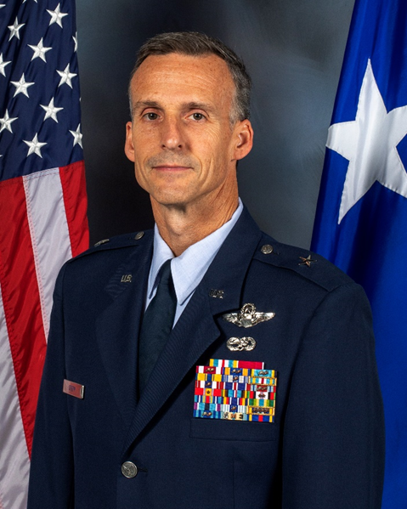Brig. Gen. Joseph H. Stepp IV is the Assistant Adjutant General for Air and Commander of the North Carolina Air National Guard, Raleigh, North Carolina. He is the primary advisor to the Adjutant General on all programs, strategic planning and operations affecting the North Carolina Air National Guard. As Commander he is responsible for the readiness, training and equipping of more than 1,400 Airmen in the 23 units of the North Carolina Air National Guard. General Stepp is also dual-hatted as the Air National Guard Assistant to the Director of Operations, Air Mobility Command (AMC/A3), Scott Air Force Base, Illinois.

General Stepp was commissioned in 1993 through the Air Force ROTC program at North Carolina State University. General Stepp has served as a C-130H3 Instructor and Evaluator Pilot, Modular Airborne Fire Fighting System Instructor Pilot, and a variety of operational assignments to include Chief of Weapons and Tactics, Wing Plans Officer, Aircraft Maintenance Squadron Commander, Airlift Squadron Commander, Operations Group Commander and Air Reserve Forces Liaison Officer to United States Transportation Command.

General Stepp has significant combat operations and staff experience supporting multiple contingencies, including Operations JOINT FORGE, ENDURING FREEDOM and IRAQI FREEDOM. He is a command pilot with more than 5,900 flying hours in the C-130E, C-130H3 and C-17A aircraft, including more than 460 combat hours. Prior to his current position, the General served as the 145th Airlift Wing Commander, Charlotte Air National Guard Base, North Carolina.

**EDUCATION**

1993 Bachelor of Science, Agricultural Business Management, North Carolina State University, Raleigh, N.C.

2000 Squadron Officer School (SOS), Maxwell Air Force Base (AFB), Ala.

2004 Distinguished Graduate, U.S. Air Force Weapons School, C-130 Weapons Instructor Course, Little Rock AFB, Ark.

2008 Air Command and Staff College (ACSC), Maxwell AFB, Ala., by correspondence

2012 Air War College (AWC), Maxwell AFB, Ala., by correspondence

2015 Director of Mobility Forces Course (DIRMOBFOR), Hurlburt Field, Fla.

2015 Reserve Component National Security Course (RCNSC), National Defense University, Fort Lesley J. McNair, Washington, D.C.

2018 Master of Science, National Resource Strategy, Dwight D. Eisenhower School for National Security and Resource Strategy, National Defense University, Fort Lesley J. McNair, Washington, D.C.

2023 General and Flag Officer Homeland Security Executive Seminar (GFOS), Harvard Kennedy School, Cambridge, Mass.

2023 National Security Studies Management Course (NSSMC), Syracuse Maxwell School of Citizenship and Public Affairs, Syracuse, N.Y.

2023 Senior Leader Orientation Course (SLOC), Joint Base (JB) Andrews, Md.

**ASSIGNMENTS**

1. February 1994 - June 1994, Student, Aircraft Maintenance and Munitions Officer Course, Sheppard Air Force Base (AFB), Texas

2. June 1994 - April 1996, Maintenance Officer, 27th Component Repair Squadron, Cannon AFB, N.M.

3. April 1996 - July 1997, Student, Joint Specialized Undergraduate Pilot Training, Columbus AFB, Miss.

4. July 1997 - December 1997, Student, C-130 Pilot Initial Qualification, 53rd Airlift Squadron, Little Rock AFB, Ark.

5. December 1997 - August 2000, C-130H3 Pilot, 156th Airlift Squadron, Charlotte Air National Guard Base (ANGB), N.C.

6. August 2000 - April 2003, C-130H3 Aircraft Commander, 156th Airlift Squadron, Charlotte ANGB, N.C.

7. April 2003 - January 2004, Tactics Officer and C-130H3 Instructor Pilot, 156th Airlift Squadron, Charlotte ANGB, N.C.

8. January 2004 - June 2004, Student, C-130 Weapons Instructor Course, United States Air Force Weapons School, Little Rock AFB, Ark.

9. June 2004 - August 2009, Chief, Weapons and Tactics and C-130H3 Instructor and Evaluator Pilot, 145th Operations Support Squadron, Charlotte ANGB, N.C.

10. August 2009 - August 2013, Wing Plans Officer and C-130H3 Evaluator Pilot, 145th Airlift Wing, Charlotte ANGB, N.C.

11. August 2013 - May 2014, Commander, 145th Aircraft Maintenance Squadron, Charlotte ANGB, N.C.

12. May 2014 - June 2015, Commander, 156th Airlift Squadron, Charlotte ANGB, N.C.

13. June 2015 - July 2017, Commander, 145th Operations Group, Charlotte ANGB, N.C.

14. July 2017 - June 2018, Student, Dwight D. Eisenhower School for National Security and Resource Strategy, National Defense University, Fort Lesley J. McNair, Washington, D.C.

15. June 2018 - June 2020, Air Reserve Forces Liaison Officer to United States Transportation Command, Operations Directorate, Scott AFB, Ill.

16. June 2020 - August 2020, Director of Operations for Air, Joint Force Headquarters, Raleigh, N.C.

17. August 2020 - May 2022, Commander, 145th Airlift Wing, Charlotte ANGB, N.C.

18. May 2023 - Present, Assistant Adjutant General for Air, Joint Force Headquarters, Raleigh, N.C.; dual-hatted, January 2024 - Present, Air National Guard Assistant to the Director of Operations, Air Mobility Command (AMC/A3), Scott AFB, Ill.

**SUMMARY OF JOINT ASSIGNMENTS**

1. June 2018 - June 2020, Air Reserve Forces Liaison Officer to United States Transportation Command, Operations Directorate, Scott AFB, Ill. as a colonel

**FLIGHT INFORMATION**

Rating: command pilot

Flight hours: more than 5,900 including 460 combat hours

Aircraft flown: T-37B, T-1A, C-130E, C-130H3 and C-17A

**MAJOR AWARDS AND DECORATIONS**

Defense Superior Service Medal

Legion of Merit

Meritorious Service Medal with two oak leaf clusters

Air Medal with six oak leaf clusters

Aerial Achievement Medal with six oak leaf clusters

Air and Space Commendation Medal

Air and Space Achievement Medal with oak leaf cluster

**OTHER ACHIEVEMENTS**

1997 Distinguished Graduate, Air Education and Training Command, Commander’s Trophy, Military Training Award, Academic Excellence Award, Joint Specialized Undergraduate Pilot Training

2000 Distinguished Graduate, C-130 Aircraft Commander Qualification Training

2004 Distinguished Graduate, Top Flyer Award, Academic Excellence Award, C-130 Weapons Instructor Course

2024-Present, Air Reserve Forces Policy Committee Member

**EFFECTIVE DATES OF PROMOTION**

Second Lieutenant Sept. 18, 1993

First Lieutenant Sept. 18, 1995

Captain March 28, 1998

Major Feb. 2, 2003

Lieutenant Colonel Aug. 2, 2008

Colonel June 5, 2015

Brigadier General May 7, 2023

(Current as of October 2024)